**Note:** Run on apify first and then use get node on n8n (follow the steps below). This will save you a lot of api hit limits, time and $$ (keeps you away from timeouts and testing)

1. Step 1 - Go to Apify and select the google map scrape of your choice.   
  
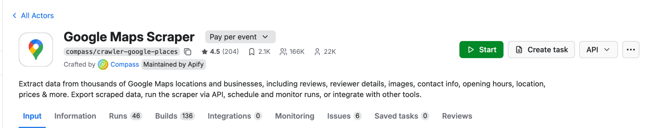

2. Step 2 - Enter keyword or keywords of the niche and specify the location you want to scrape  
  
Note: No of places to extract per search term or url I left it empty so i dont miss out on anything

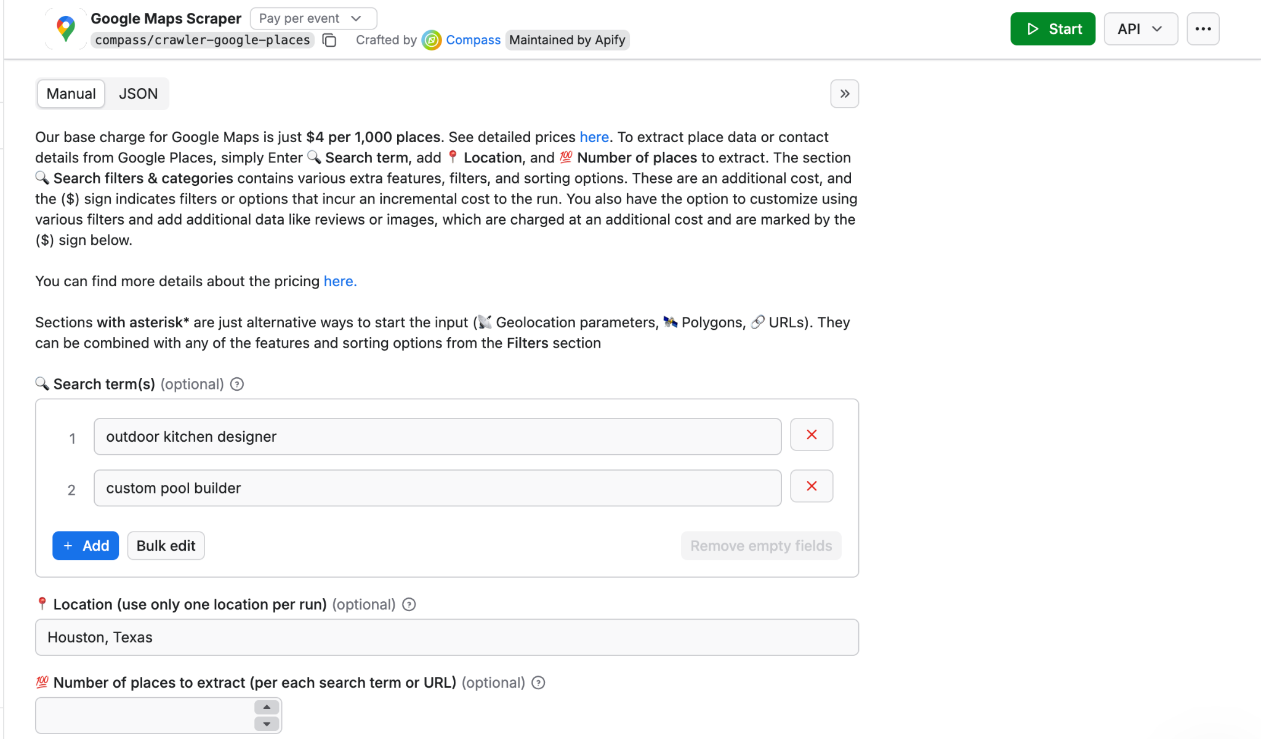

3. Step 3 - Turn on skip closed spaces so you can save $$ while scraping

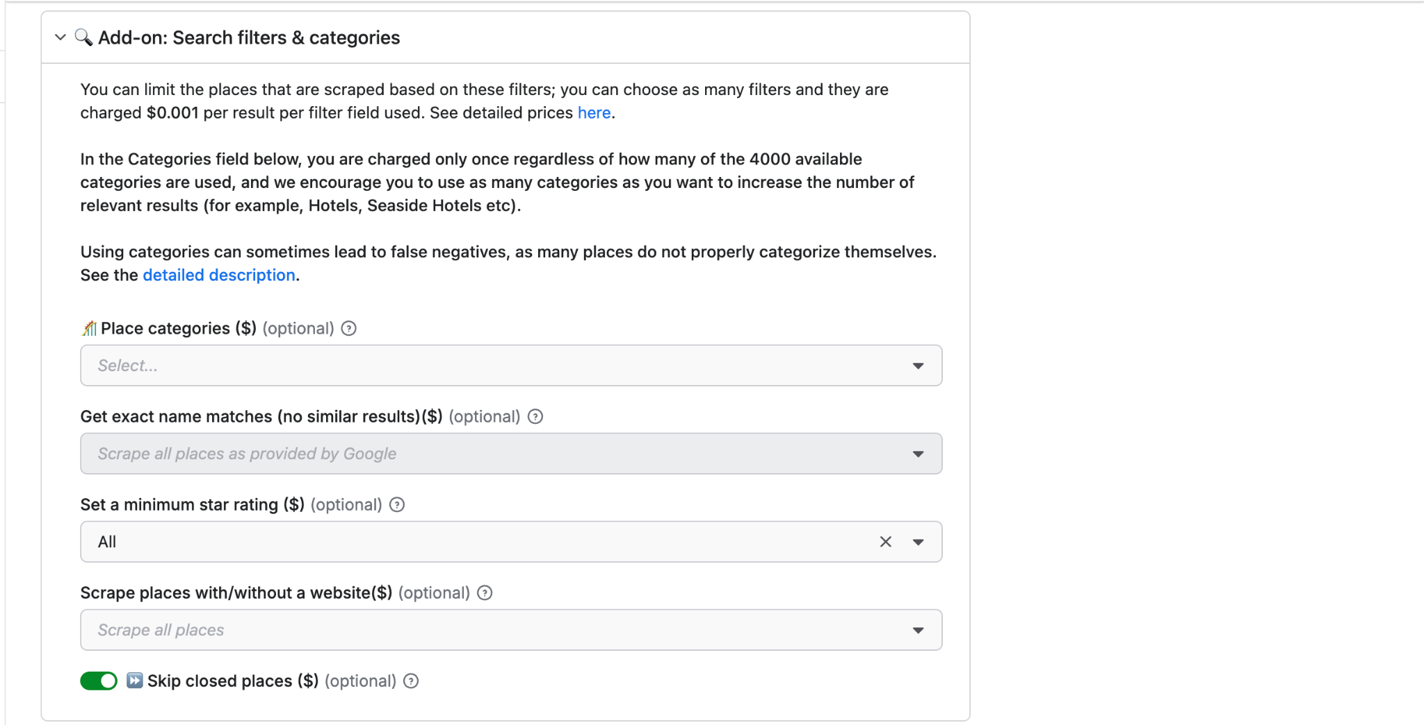

4. Step 4 - If you are not scraping restaurants and scraping some details of the pages only turn this “Scrape place detail page on”

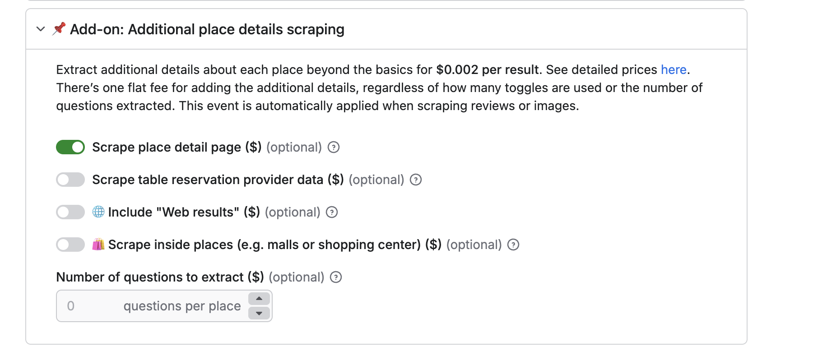

5. Step 5 - Turn on add on: company contacts if you want the business details as well

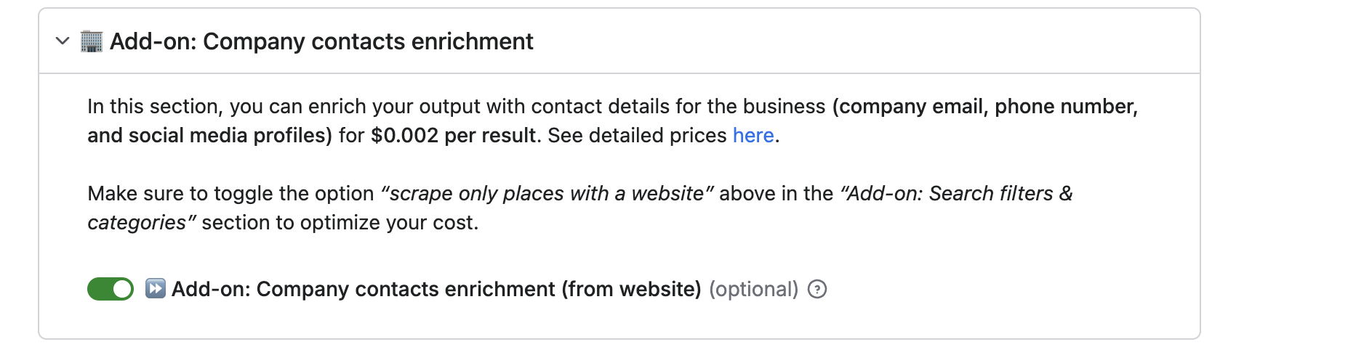

6. Step 6 - Make sure you change no of reviews accordingly and follow the same setup like below 100 days is a good time period

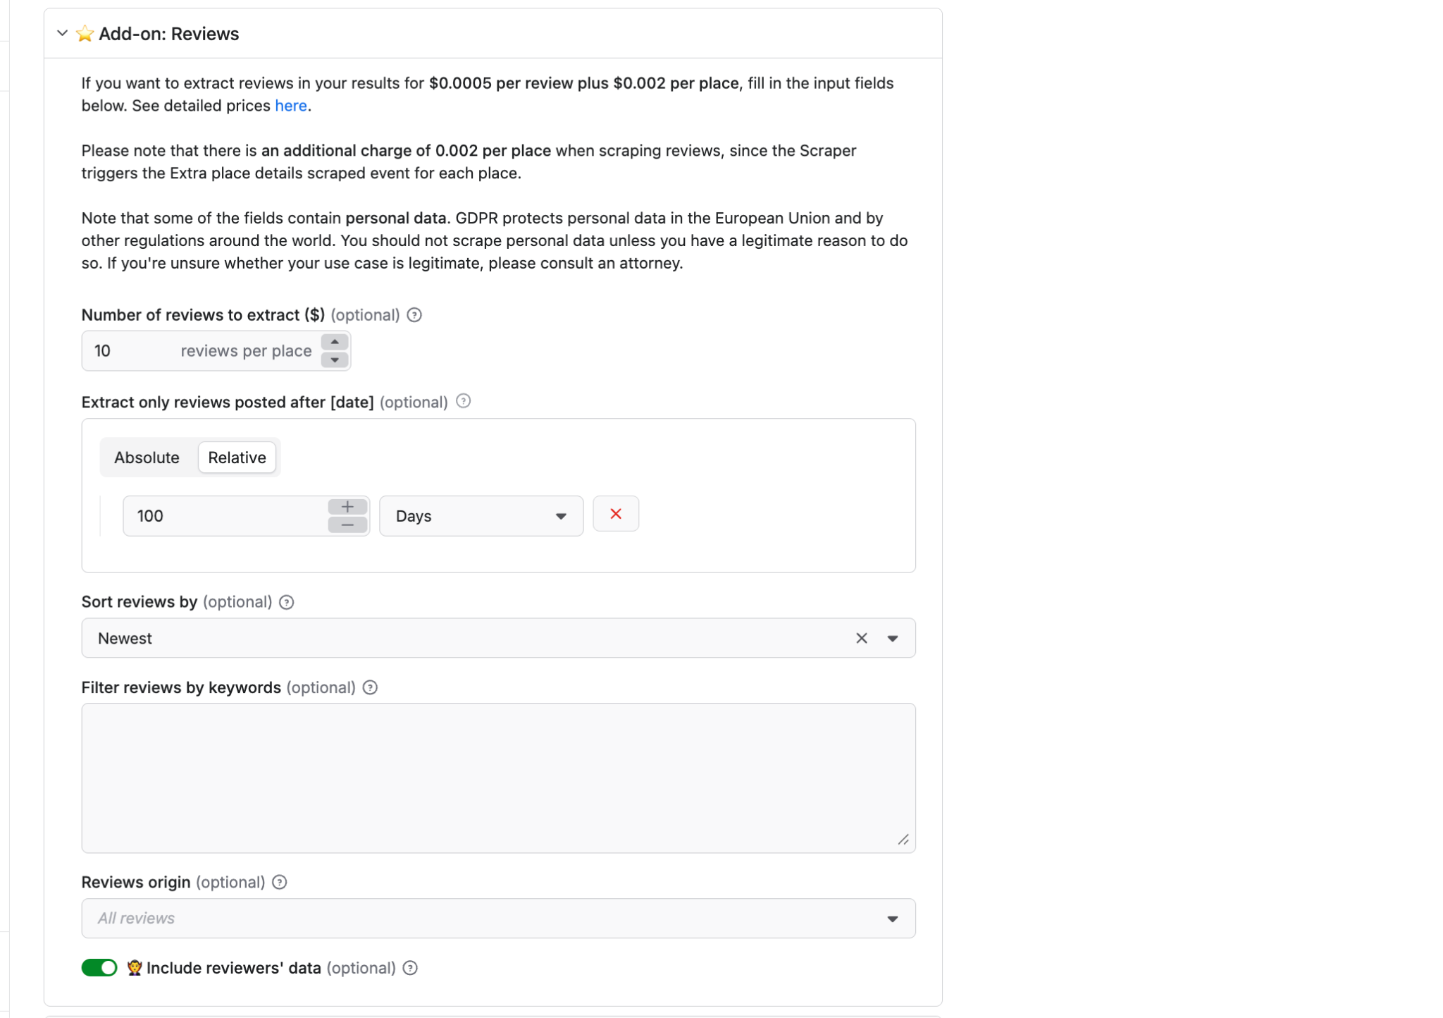

Note: If you are changing the data setup above you may have to make changes in the code nodes of the workflow

**7.** Step 7 -Overall json example(you can simply copy paste this in the json of apify and change the highlighted sections (location and search string)

{

"includeWebResults": false,

"language": "en",

"locationQuery": "Houston, Texas",

"maxImages": 0,

"maxReviews": 10,

"reviewsSort": "newest",

"reviewsStartDate": "100 days",

"scrapeContacts": true,

"scrapeDirectories": false,

"scrapeImageAuthors": false,

"scrapePlaceDetailPage": true,

"scrapeReviewsPersonalData": true,

"scrapeTableReservationProvider": false,

"searchStringsArray": [

"outdoor kitchen designer ",

"custom pool builder"

],

"skipClosedPlaces": true

}



8. Step 8 - To copy past the dataset id  
  
Follow the steps  
  
a. Go to run >> select the run of actor  
b. Select storage and copy the dataset id

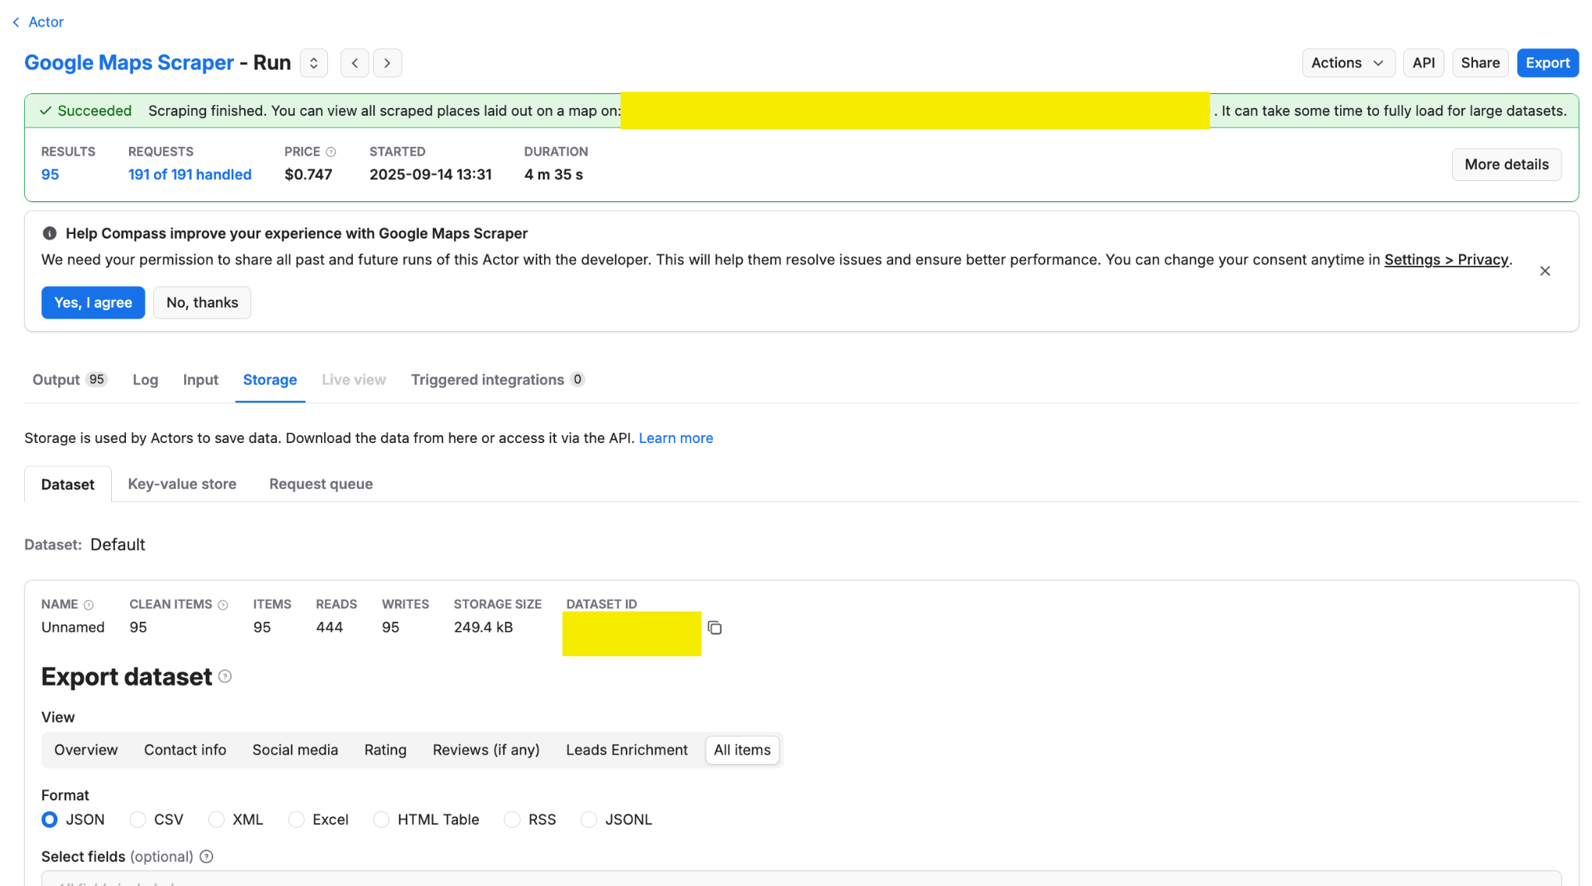

9. Step 9- Go to n8n http node in the URL >> paste the data set id and API of your apify  
  
